CHEM4680
Organometallic Chemistry

COURSE SYLLABUS

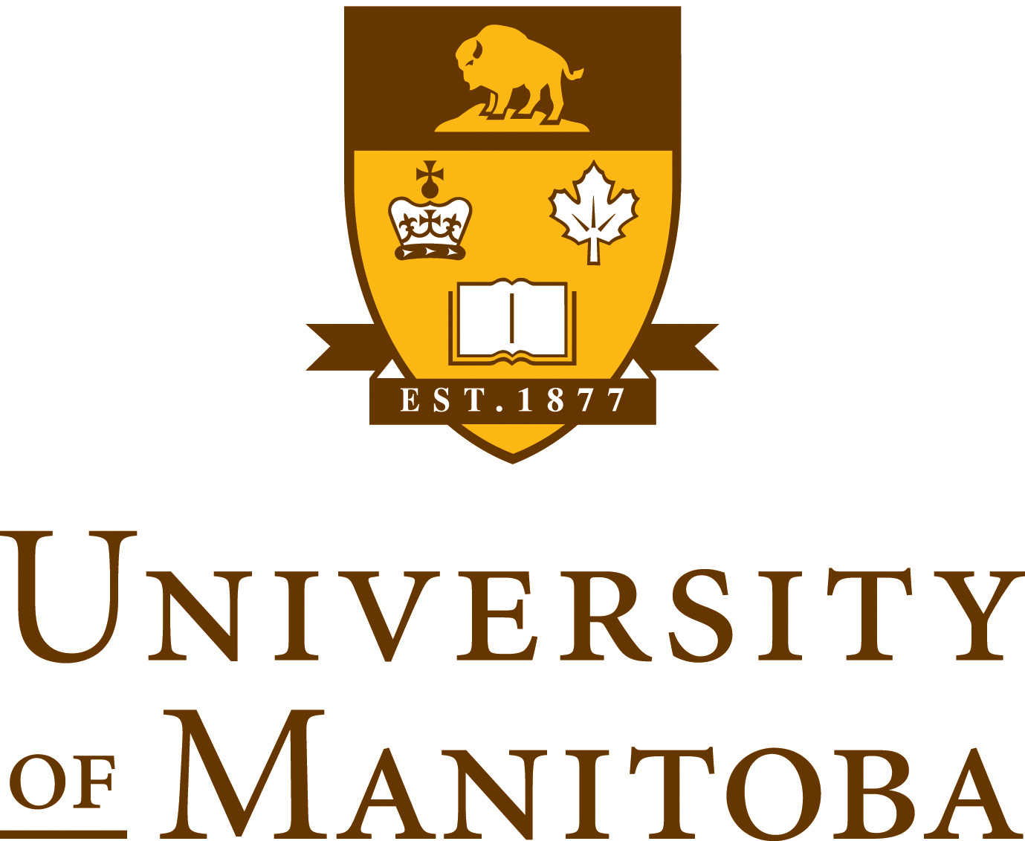
University of Manitoba
Faculty of Science
Department of Chemistry

TABLE OF CONTENTS
COURSE DETAILS 3
Lecture Instructor Contact Information 3
Lab Instructor Contact Information 3
General Course Information 4
Course Goals 4
Using Copyrighted Material 4
Recording Class Lectures 4
Textbook, Readings, Materials 5
Course Technology 5
Class Communication 5
Academic Integrity 5
Students Accessibility Services 6
Class Content 6
Course Evaluation Methods 6
Grading 7

COURSE DETAILS

Course Title & Number: | CHEM 4680 – Organometallic Chemistry
Number of Credit Hours: | 3
Class Times & Days of Week: | MWF, 11:30-12:20 pm
Location for classes/labs/tutorials: | Tier 503
Pre-Requisites: | CHEM 3400 (C), or CHEM 3380 (C), or CHEM 3390 (C)

Lecture Instructor Contact Information
Instructor Name: | David Herbert
Office Location: | 570 Parker
Office Hours or Availability: | Scheduled office hours: Friday (preceding class) 10:30-11:30 or by appointment (e-mail to arrange)
Email: | david.herbert@umanitoba.ca
Research Website: | http://home.cc.umanitoba.ca/~dherbert/
Course Website: | https://universityofmanitoba.desire2learn.com/d2l/login

General Course Information
This course will cover chemistry of organometallic compounds of the transition metals and representative elements, including (time-permitting) main group/rare-earth metals.

The course will discuss the development of this relatively young field and highlight its relevance to bioinorganic chemistry, modern synthesis, catalysis, energy and materials.

Course Goals
You should emerge from this course with a foundational knowledge of organometallic chemistry, that is the chemistry of complexes containing metal-carbon (and related elements) bonds.

Building on concepts from prerequisite courses (e.g., CHEM3400) including coordination chemistry, ligand field theory and related topics, by the end of this course you should feel confident estimating the stability and reactivity of organometallic complexes based on electronic configuration, ligand identity and other structural information.

You will learn the “standard” organometallic reaction steps considered part of the “toolbox” of organometallic chemistry, and be able to propose reasonable mechanisms for organometallic reactions, including metal-catalyzed reactions. Similarly, you will be able to use steric and electronic arguments to predict how changes in reactants, metals or ligands might affect the outcome of a reaction or a compound’s properties.

In these ways, this course will provide a strong foundation for understanding the hugely important field of organometallics as it pertains to homogeneous catalysis, bioinorganic chemistry and materials science.

Using Copyrighted Material
Please respect copyright. We may use copyrighted content in this course. I have ensured that the content I use is appropriately acknowledged and is copied in accordance with copyright laws and University guidelines. Copyrighted works, including those created by me, are made available for private study and research and must not be distributed in any format without permission. Do not upload copyrighted works to a learning management system (such as UM Learn), or any website, unless an exception to the Copyright Act applies or written permission has been confirmed. For more information, see the University’s Copyright Office website at http://umanitoba.ca/copyright/ or contact um_copyright@umanitoba.ca.

Recording Class Lectures
David Herbert and the University of Manitoba hold copyright over the course materials, presentations and lectures, which form part of this course, unless otherwise stated. No audio or video recording of lectures or presentations is allowed in any format, openly or surreptitiously, in whole or in part without permission from David Herbert. Course materials (both paper and digital) are for the participant’s private study and research.

Textbook, Readings, Materials
Robert H. Crabtree, The Organometallic Chemistry of the Transition Metals, 6th or 7thEd. (Wiley) is available from the campus bookstore.

Electronic copies of lecture notes will be provided, and may include textbook references. These references will be to later editions of this textbook and it is the responsibility of the student to ensure that content or sections accessed from previous editions are up to date.

Supplementary material to the lectures will be posted on UMLearn.

Course Technology
It is the general University of Manitoba policy that all technology resources are to be used in a responsible, efficient, ethical and legal manner. The student can use all technology in classroom setting only for educational purposes approved by instructor and/or the University of Manitoba Disability Services. Student should not participate in personal direct electronic messaging / posting activities (e-mail, texting, video or voice chat, wikis, blogs, social networking (e.g. Facebook) online and offline “gaming” during scheduled class time. If student is on call (emergency) the student should switch his/her cell phone on vibrate mode and leave the classroom before using it. (©S Kondrashov. Used with permission)

Class Communication
The University requires all students to activate an official University email account. For full details of the Electronic Communication with Students please visit: http://umanitoba.ca/admin/governance/media/Electronic_Communication_with_Students_Policy_-_2014_06_05.pdf

Please note that all communication between myself and you as a student must comply with the electronic communication with student policy (http://umanitoba.ca/admin/governance/governing_documents/community/electronic_communication_with_students_policy.html).

You are required to obtain and use your U of M email account for all communication between yourself and the university.

Academic Integrity
The University of Manitoba treats violations of academic integrity such as plagiarism, cheating or impersonation of another student, as serious academic offenses, subject to severe penalty. These policies are available in detail on-line at the web address listed, from the University of Manitoba website, and in the general academic calendar. In addition, see the Statement on Academic Integrity included below.
http://umanitoba.ca/science/undergrad/resources/webdisciplinedocuments.html

Students Accessibility Services

Student Accessibility Services
If you are a student with a disability, please contact SAS for academic accommodation supports and services such as note-taking, interpreting, assistive technology and exam accommodations. Students who have, or think they may have, a disability (e.g. mental illness, learning, medical, hearing, injury-related, visual) are invited to contact SAS to arrange a confidential consultation.
Student Accessibility Services http://umanitoba.ca/student/saa/accessibility/
520 University Centre – (204)474 7423
Student_accessibility@umanitoba.ca

Course Content
This course will provide you with the tools to understand the structure, bonding and reactivity of organometallic complexes.

Specific topics to be covered include (subject to change):

- Making sense of organometallics: metallic elements of periodic table (review), coordination number and geometry (review), ligand classes (review), crystal field/ligand field theory (review), σ/π bonding, back-bonding, electron counting, multi-electron/multi-centre bonding

- Organometallic ligands: alkyls and hydrides, π-complexes, carbenes/carbynes

- Reactions of M-C bonds: oxidative addition/reductive elimination, insertion/elimination, addition and abstraction

- Putting it all together: homogeneous catalysis, catalytic cycles, alkene isomerization, hydrogenation, hydroformylation, coupling reactions, alkene metathesis, olefin polymerization, photoredox catalysis/electrocatalysis (time permitting)

- Metal carbon bonds in Nature (bioinorganic chemistry)

- Physical methods in organometallic chemistry (time permitting)

Course Evaluation Methods
Evaluation will be based on the following components:
- Assignments (3): 30%
- In-Class Mid-Term (Tentative date: October 18th* *date may change!*): 20%
- Final Exam: 50%

Assignments will be posted on UMLearn. There will be no make-up assignments. Late assignments will not be accepted for marking without prior permission from the instructor; such permission may be granted at the discretion of the instructor at a penalty of 10% per day. Extensions must be arranged well in advance of the due date and extensions may not be granted within 72 hours of the due date. Late assignments will not be accepted after the posting of the answer keys.

An in-class mid-term examination will be scheduled prior to the voluntary withdrawal date (tentative date: October 18th* *date may change!). There will be no opportunity to re-write a missed mid-term test. Upon approval of a written excuse, the marks from a missed midterm may be added to the final exam, making it worth 70%.

A 3-hour final exam will be held during the December examination period and will cover all aspects of the course, including material from the lectures, assignments, textbook readings. The time and location will be set by the Student Records Office. It is your responsibility to be available for any examination scheduled during the official examination period. Final examination deferrals must be processed by the Faculty of Science Office.

Feedback prior to the voluntary withdrawal date will consist of a mid-term test and at least one assignment.

Grading
Marks between 50-100% will be assigned a letter grade between “D” and “A+”, as follows:

≥90.0% A+
80.0-89.9% A
73.0-79.9% B+
66.0-72.9% B
60.0-65.9% C+
55.0-59.9% C
50.0-54.9% D
<50.0% F

