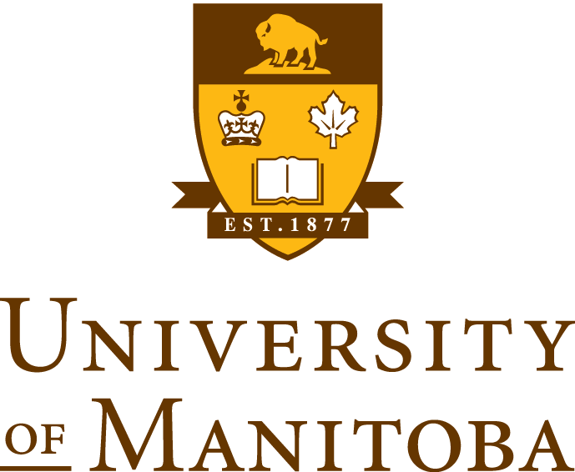
  - CHEM 3580: Modern Physical Organic Chemistry

Instructor Information
Instructor | Email | Office Location | Office Hours
Rebecca Davis | Rebecca.Davis@umanitoba.ca | Parker 552 | When the door is open
Teaching Assistant | Email | Office Location | Office Hours
Jorge Dourado | decarvjm@myumanitoba.ca | Parker 556 | TBA

General Information

Description

This course will examine the tools - both theoretical and experimental - that the modern organic chemist has at his or her disposal for elucidating mechanisms.

Expectations and Goals
This class is not about memorization. It is about developing analytical thinking and problem solving skills.

Prerequisite:
The prerequisite for this course is CHEM 2220 with a grade of C or better. Students must also have taken or be taking CHEM 2290.

Course Materials

Suggested Texts
Anslyn, E. V.; Dougherty, D. A. Modern Physical Organic Chemistry. University Science Books, 2006.
Fleming, I. Molecular Orbitals and Organic Chemical Reactions, John Wiley & Sons, Ltd, 2010.

Other Materials
Molecular Modeling Kit

Great Source of Practice Problems
http://evans.rc.fas.harvard.edu/problems/index.cgi

Grading Scheme

Assignments (30%)
There will be four assignments in this course. You will be give one week to complete each assignment. Homework is due at the beginning of the class period on the given due date. After that time, homework will not be accepted.

Final Exam (40%)
The final exam will be cumulative. You must take the final exam in order to pass this class.

Laboratory (30%)
An overall grade of 60% on the laboratory assignments must be achieved in order to receive a passing grade for this course.

Policies

Laboratory
All laboratory assignments must be completed in order to receive a passing grade for this course.

Make-up Exams
No early or late exams (midterms or final) will be given. For students with a legitimate reason for missing a midterm (written documentation of the reason for such an absence is required), the final examination (since it is cumulative) will be scaled to count for 55% of the grade.

Mutual Respect
We are all adults and should treat each other as such. Cheating of any kind (including plagiarism, beginning an exam early, continuing to write on an exam after time is called) will not be tolerated. For information on the University policies on Academic Dishonesty see:
http://umanitoba.ca/faculties/science/undergrad/resources/webdisciplinedocuments.html

Outline

- MO Theory
  - Bonding theories
  - Conformational Analysis
    - sterics, strain, electronics, noncovalent interactions
    - chirality and topicity
    - symmetry as mechanistic tool

- Thermodynamics
  - potential energy surfaces
  - reactive intermediates
    - carbanions, carbocations, carbenes etc.

- Kinetics
  - chemical kinetics, rate theory
  - kinetic vs. thermodynamic control
  - Hammond postulate and Curtin-Hammett principle
  - isotope effects
  - linear free energy relationships

- Pericyclic Reactions
  - MO Theroy
  - Woodward Hoffmann Rules
  - Cycloadditions, Sigmatropic Shifts, Electrocyclizations, Ene Reactions

